|  |  |  |  |
| --- | --- | --- | --- |
| CH2=CH-OH |  |  |  |
|  | anilín |  | dimetylamín |
| CF2=CF2 |  |  | vynilchlorid |
|  | acetón |  | Kyselina benzoová |
|  |  | CH3 - CH2 – NO2 |  |
|  | cyklohexanón |  | antracén |

Pomenujte a označte hlavný reťazec.

1,2-etyl,5-metyl-hex-2-én

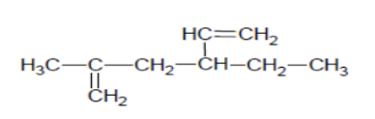

2-metylpent-3-ín